|  |  |
| --- | --- |
| First name: |  |
| Last name: |  |
| Email address: |  |
| Phone number: |  |
| Mobile number: |  |
| Date of birth: |  |
| Company: (If relevant) |  |
| Full address: |  |
| Postcode: |  |
| Course Details: | FAA Level 3 Award In Emergency First Aid at Work (QCF) |
| Course Date: |  |
| Course Venue: |  |
| Any additional needs / medical conditions / allergies: |  |
| Have you attended a First Aid course in the past: |  |
| How did you hear about us: |  |

Logos round 6.pdf

**Booking Information:**

I confirm I have read and agree to the [Terms and Conditions](https://www.mcfirstaidtraining.co.uk/terms-conditions" \t "_blank):

Yes

**Payment Information:**

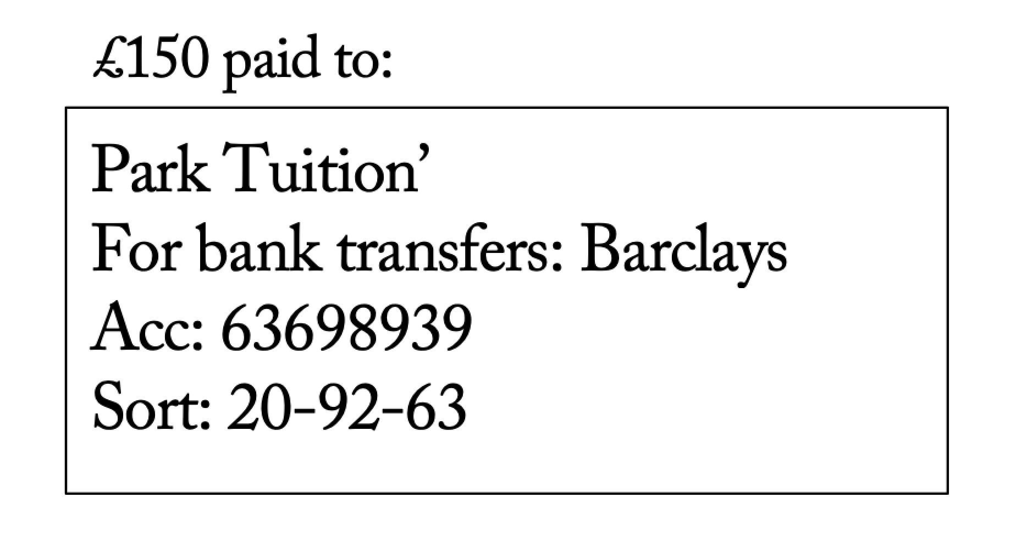

Please return this document to:

[*carol.parktuitionfirstaid@gmail.com*](mailto:carol.parktuitionfirstaid@gmail.com)